Password Refresh using Login Assistance:
STEP 1: Enter Login Assistance on your main oracle screen to refresh your oracle password.
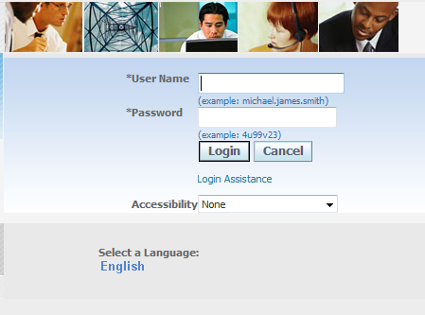
1
Press Login Assistance
STEP 2: Enter Your Oracle I.D in the User Name Field and press Forgot Password.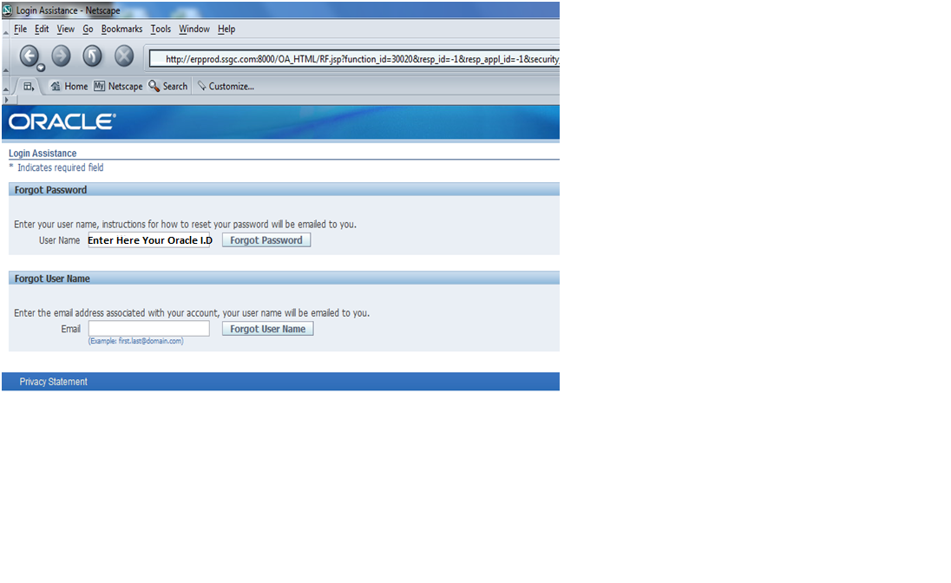
3
2

STEP 3: Password-reset request will be submitted. An email with instructions will be sent to you within 5 minutes.
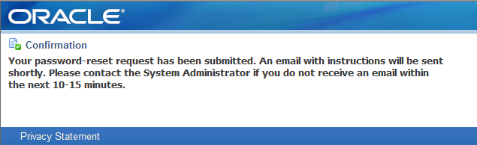

STEP 4: After 5 Minutes an E-mail comes to your lotus I.D open it and Click Reset Your Password Link
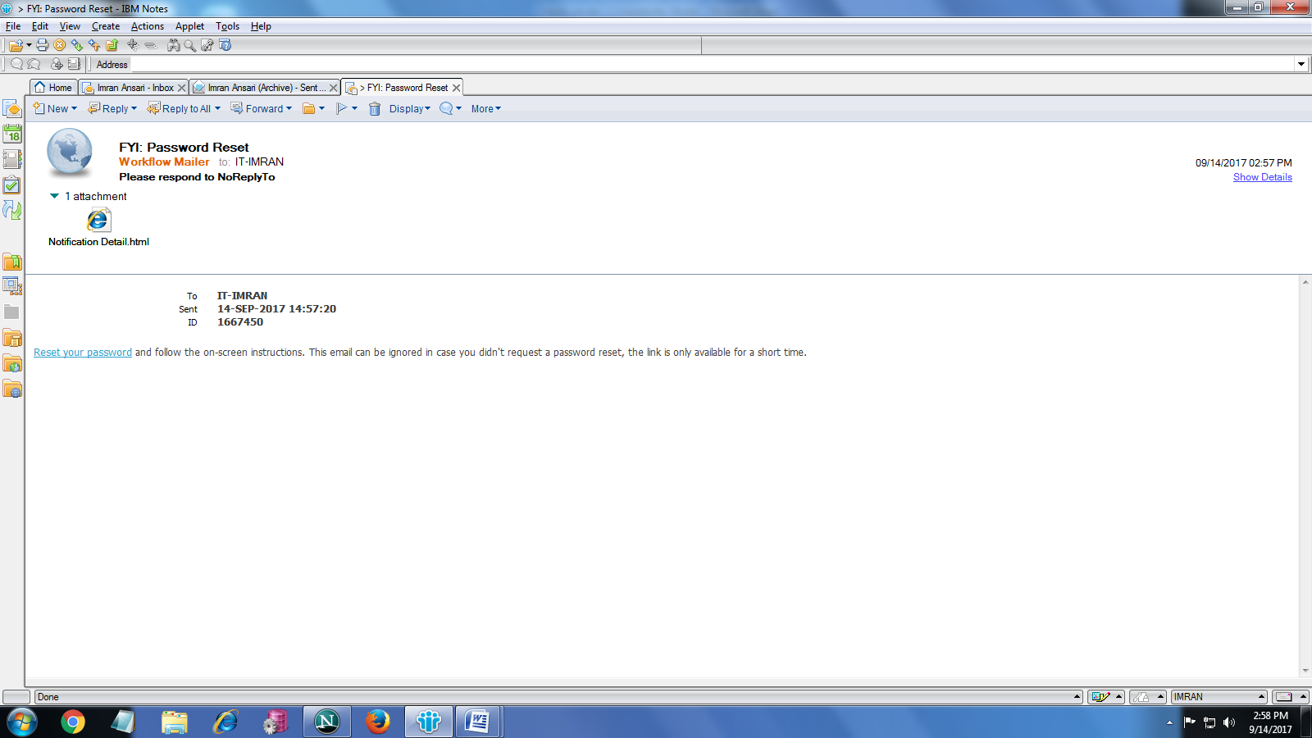
Press Here
4

STEP 5: Enter your Oracle I.D then Enter your New Password and then Re-Enter New Password for Confirmation.
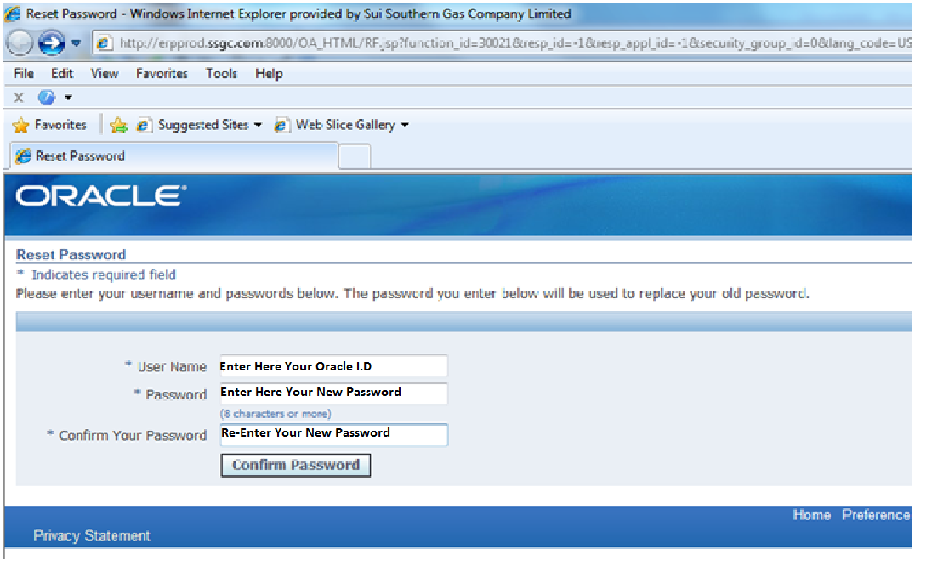
7
5

6

